CE2107 Lab4 Assignment Sheet (to be submitted to NTULearn before next lab)

Name: Dayna Chia Lab Group: SE1 Date: 30/10/22

1. Section 6.1. What is the issue when an obstacle is placed too close to the IR sensor? What can you do to prevent such ambiguity?

When an obstacle is placed too close to the IR sensor, the sensor value recorded can correspond to two different distances due to the non-monotonic behaviour of the sensor. To prevent such ambiguity, distances from 0 to 5mm and above 500mm are ignored.

1. Section 6.1. What is the purpose of the 10uF decoupling capacitor?  
   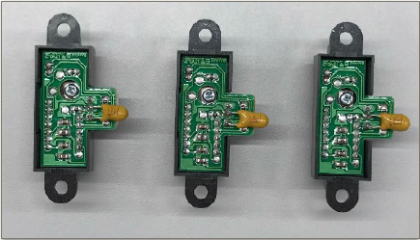

Since the sensor is noisy, the decoupling capacitor helps to keep voltage relatively stable by providing power when there is a voltage drop and by absorbing excess energy when there is a voltage spike.

1. Section 6.2. Which port pins is ADC Ch12, 16 and 17 inputs mapped to? What is the PSELx settings required to configure the pins to ADC function?

Ch12 mapped to Port pin 4.1

Ch16 mapped to Port pin 9.1

Ch17 mapped to Port pin 9.0

Settings required: PSEL1 = 1, PSEL0 = 1

P4->SEL1 |= 0x02;

P4->SEL0 |= 0x02;

P9->SEL1 |= 0x03;

P9->SEL0 |= 0x03;

1. Section 6.2. With respect to the ADC on MSP432, what are the two stages involved in every Analog to Digital Conversion of an Analog signal?

Sample-and-Hold (Stage 1): ADC samples the input signal voltage

Conversion (Stage 2): Detected voltage level passed into SAR ADC for digitization

1. Section 6.3. What does the function LPF_Calc() does? What are the initial values of the buffer associated with LPF_Calc()? Why do we need this function?

The LPF_Calc() function takes new ADC data as input, stores it in an array with previous ADC data values, removes the oldest ADC value and returns an output value that is the mean of all the values in the array.

The initial values of the buffer are the raw values from each channel (raw17, raw12, raw16).

This function serves as a Low Pass Filter to remove noise. By taking the mean of previous and current ADC values, any rapid change in ADC value is averaged out and ADC values that are too high are essentially “filtered” out.

1. Section 6.3. Describe the algorithm you used to estimate the actual distance based on the IR Sensor value.

IR Sensor values are taken at fixed distances between the sensor and an obstacle. The measured distances are then plotted against the IR Sensor values, which gives a hyperbolic curve. The equation derived from the curve is then used in the distance calculate functions.

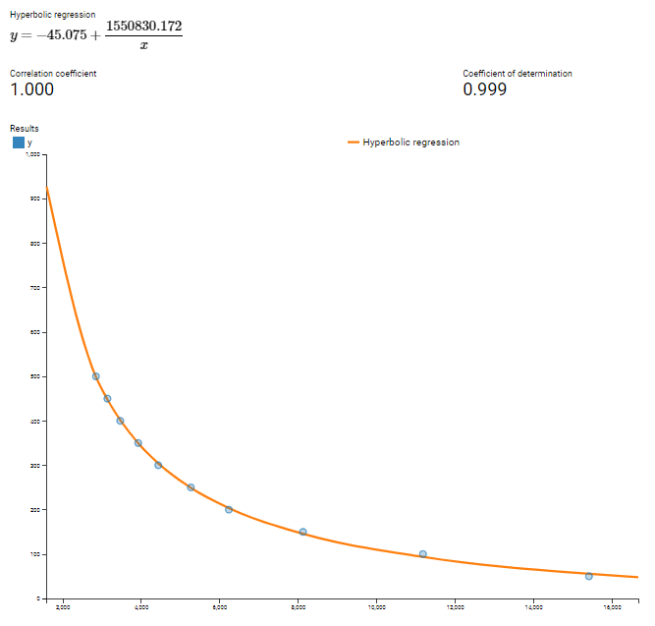

1. Section 7.2. Which timer capture input (Timer and Channel number) does P10.4 and P10.5 correspond to?

P10.4 corresponds to Timer 3 Channel 0

P10.5 corresponds to Timer 3 Channel 1

1. Section 7.2. Which edge (falling, rising, both) is the timer input capture configured to trigger on? What happens when a capture event occurs?

Rising edge

When a capture event occurs (rising edge of square wave output from tachometer), the timer count value is stored in the channel register.

1. Section 7.2. Why is the calculated value of pulse duration, derived from the timer capture values, not a constant value but seemed to keep changing?

The square pulses that are output has a frequency that is proportional to the speed in which the motor is moving. Due to external forces like friction opposing motion, the motor may not be moving at constant speed, which is why the calculated value of pulse duration may not be a constant value.